Arduino WIFI
ATTENTION, pas mal de problèmes avec ce module, blocages, pertes de connexion...

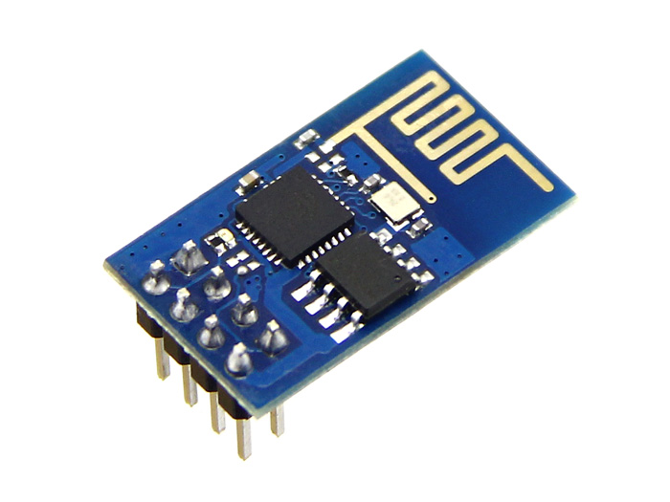
Module ESP8266
ESP8266 ESP-01

Cablage
Vue de dessous du composant Arduino
+-----------------------------+
| GND TX | TX <-----> 10
| 0 3,3V |
| 0 0 |
| RX 3,3V | RX <-----> 11
+-----------------------------+
ATTENTION, l’alimentation est du 3,3 V

Exemple : mini serveur web
#include <SoftwareSerial.h>

// A MODIFIER
#define DEBUG true
#define RX 10 // broche arduino
#define TX 11 // broche arduino
#define ssid "xxxxxxxxxx"
#define password "xxxxxxxxxxxx"

String pageaccueil = "<h1>Accueil</h1>Commandes disponibles:<br>test1<br>";

// FIN DES MODIFICATIONS

SoftwareSerial ESP8266(RX, TX);

String NomduReseauWifi = ssid;
String MotDePasse = password;

void envoieAuESP8266(String commande)
{
ESP8266.println(commande);
}

void recoitDuESP8266(const int timeout)
{
String reponse = "";
long int time = millis();
while ( (time + timeout) > millis())
{
while (ESP8266.available())
{
char c = ESP8266.read();
reponse += c;
}
}
Serial.print(reponse);
}

void initESP8266()
{
Serial.println("**************** DEBUT DE L'INITIALISATION ***************");
envoieAuESP8266("AT+RST");
recoitDuESP8266(2000);
envoieAuESP8266("AT+CWMODE=3");
recoitDuESP8266(5000);
envoieAuESP8266("AT+CWJAP=\""+NomduReseauWifi+"\",\""+MotDePasse+"\"");
recoitDuESP8266(10000);
envoieAuESP8266("AT+CIFSR");
recoitDuESP8266(1000);
envoieAuESP8266("AT+CIPMUX=1");
recoitDuESP8266(1000);
envoieAuESP8266("AT+CIPSERVER=1,80");
recoitDuESP8266(1000);
Serial.println("***************** INITIALISATION TERMINEE ****************");
}

String sendData(String command, const int timeout, boolean debug)
{
String response = "";

ESP8266.print(command); // send the read character to the esp8266
long int time = millis();
while ( (time + timeout) > millis())
{
while (ESP8266.available())
{
// The esp has data so display its output to the serial window
char c = ESP8266.read(); // read the next character.
response += c;
}
}

if (debug)
{
Serial.print(response);
}
return response;
}

void setup()
{
Serial.begin(9600);
ESP8266.begin(9600);
initESP8266();
}

void loop()
{
String requete, webpage, cipSend, closeCommand;
if (ESP8266.available())
{
Serial.println("Connexion");
if (ESP8266.find("+IPD,"))
{
delay(1000);
int connectionId = ESP8266.read() - 48;
// subtract 48 because the read() function returns
// the ASCII decimal value and 0 (the first decimal number) starts at 48
if (ESP8266.find("GET /"))
{
requete = "";
char cmd = ESP8266.read();
while (cmd != ' ')
{
requete += cmd;
cmd = ESP8266.read();
}
if (requete == "")
{
webpage = pageaccueil;
}
// a dupliquer et a modifier pour les differentes commandes
else if (requete == "test1")
{
webpage = pageaccueil + "Commande test1 OK";
}
// fin des modifs
else // page erreur requete inconnue
{
webpage = pageaccueil + "Requete inconnue " + requete;
}
}

// Envoi de la reponse

cipSend = "AT+CIPSEND=";
cipSend += connectionId;
cipSend += ",";
cipSend += webpage.length();
cipSend += "\r\n";
sendData(cipSend, 1000, DEBUG);
sendData(webpage, 1000, DEBUG);

// Fermeture de la connexion

closeCommand = "AT+CIPCLOSE=";
closeCommand += connectionId; // append connection id
closeCommand += "\r\n";
sendData(closeCommand, 3000, DEBUG);
}
}
}

