Led RGB

Recherche sur Ebay :
arduino led rgb

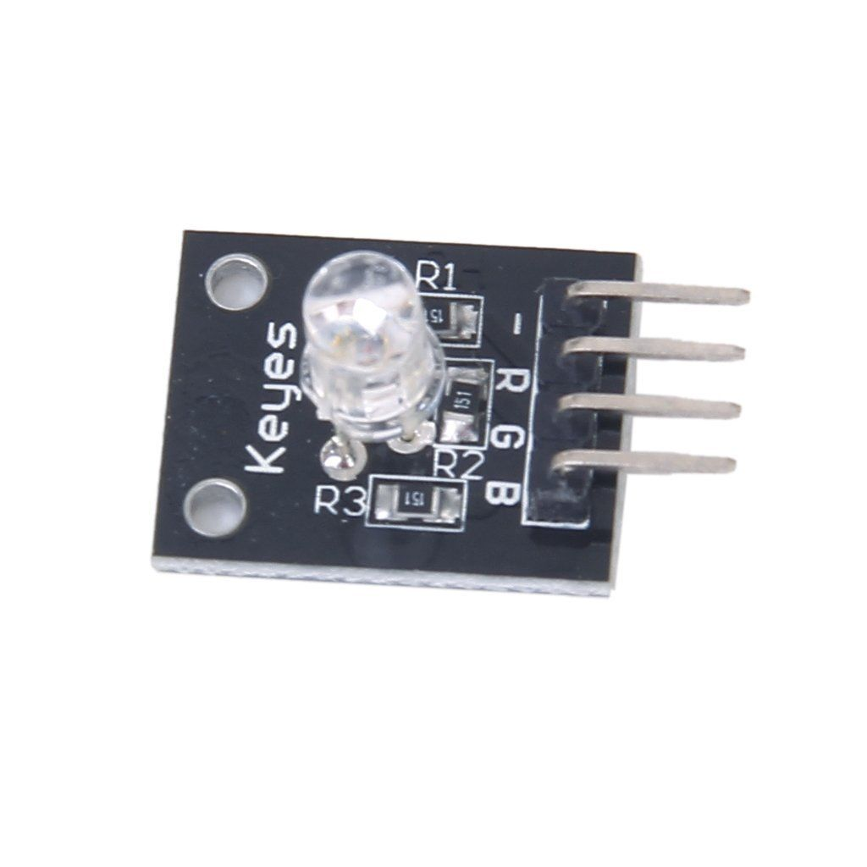
Broches
GND R G B ou GND G R B VÉRIFIER sur le composant

NE PAS OUBLIER : mettre des résistances de 220 ohms entre les 3 broches R G B et le 5V

Code :
int redPin = 9;
int greenPin = 8;
int bluePin = 10;

//uncomment this line if using a Common Anode LED
//#define COMMON_ANODE

void setColor(int red, int green, int blue)
{
#ifdef COMMON_ANODE
red = 255 - red;
green = 255 - green;
blue = 255 - blue;
#endif
analogWrite(redPin, red);
analogWrite(greenPin, green);
analogWrite(bluePin, blue);
}

void setup()
{
pinMode(redPin, OUTPUT);
pinMode(greenPin, OUTPUT);
pinMode(bluePin, OUTPUT);
}

void loop()
{
setColor(255, 0, 0); // rouge
delay(1000);
setColor(0, 255, 0); // vert
delay(1000);
setColor(0, 0, 255); // bleu
delay(1000);
setColor(255, 255, 255); // blanc
delay(1000);
setColor(0,0,0); // "noir" eteint
delay(1000);
}

